Art Breadth of Coverage - Winlaton West Lane Community Primary School
 | Nursery | Reception | Year 1 | Year 2 | Year 3 | Year 4 | Year 5 | Year 6
Autumn A  Autumn B | Introduction to PE unit 1  Introduction to PE unit 2 | Introduction to PE unit 1  Introduction to PE unit 2 | Fundamentals  Ball Skills  Target Games  Yoga | Fundamentals  Ball Skills  Invasion games  Yoga | Fundamentals Y3/4  Ball Skills Y3/4  Yoga  Basketball | gymnastics  Football  Basketball  Fitness | Badminton Y5/6  Swimming  Hockey  Swimming | tag rugby  football  Netball  Dance
Spring A  Spring B | Fundamentals: unhit 1  Fundamentals: unit 2 | Fundamentals: unhit 1  Fundamentals: unit 2 | Gymnastics  Fitness  Dance  Team building | Dance  Fitness  Gymnastics  Team Games | Dance  Handball  Gymnastics  Dodgeball | Dodgeball  Yoga  Dance  Rugby | Gymnastics  Swimming  OAA  Swimming | Fitness  Handball  Cricket  Badminton Y5/6
Summer A  Summer B | Ball skills: unit 1  Ball skills: unit 2 | Ball skills: unit 1  Ball skills: unit 2 | Net and Wall Games  Send and Receiving  Striking and fielding  Athletics | Team building  Sending and Receiving  Athletics  Striking and Fielding Games | Tennis  Athletics  OAA  Netball | Cricket  Tennis  Rounders  Athletics | Handball  Swimming  Athletics  Swimming | Volley ball Y5/6  Athletics  Rounders  OAA

,

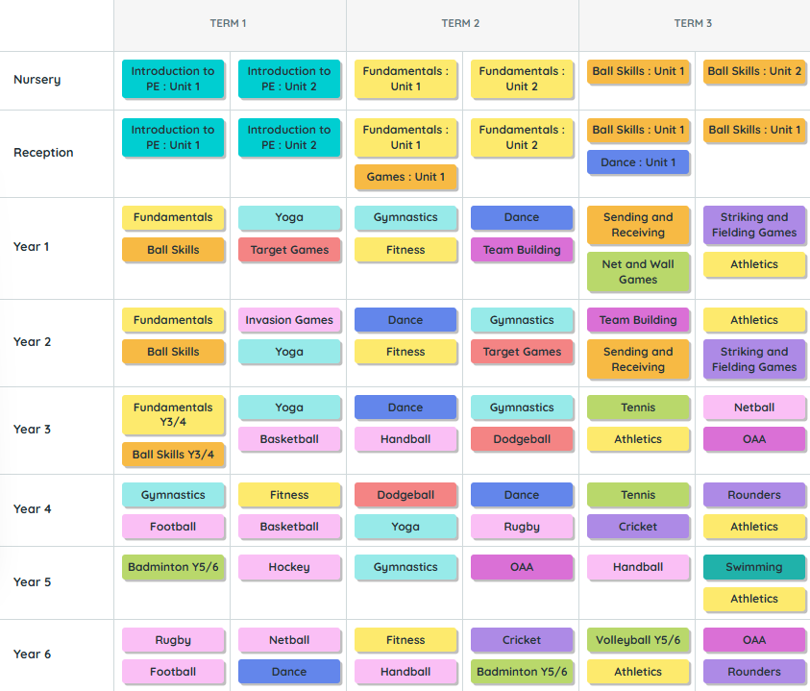
p
• Pink: Invasion Games
• Dark Blue: Target Games
• Purple: Striking and Fielding Games
• Light Green: Net and Wall Games
• Orange: Gymnastics
• Red: Dance
• Yellow: Athletics [1]

