When I am reading something, I can use the following things to help me:

I use the pictures to help me. |  |  |  |  | 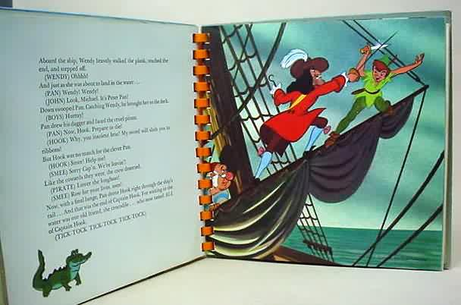
 |  | “C-A-R-P-E-T”  “CAR – PET”  “CARPET” |  |  | I sound out/blend words I don’t know.
I look for smaller words inside words. |  |  | 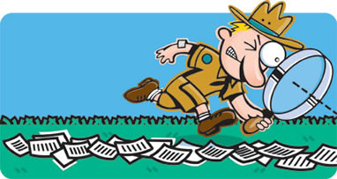  “tEACHer”
 | “en – joy – able”  “Enjoyable” |  |  | I can break words down into syllables.

When I am reading something, I can use the following things to help me:

I use punctuation to help me make sense of what I am reading.

 | I go back and read a word or sentence again if I don’t understand it.
I read on to see if I can work out the meaning of a word I don’t know | 
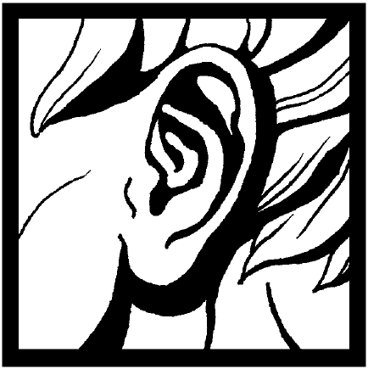 | I listen to what I am reading to see if it makes sense.

When I am reading something, I can use the following things to help me:

I check that I am right by going back to look at words carefully. | 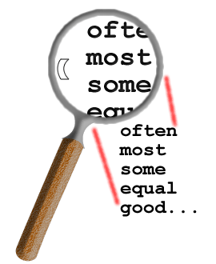
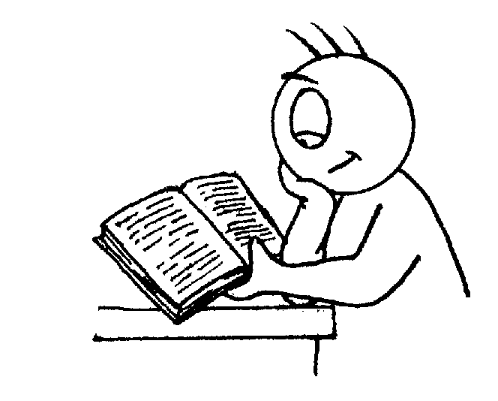 | I can tell when I’ve made a mistake and go back to try and put it right.
I ask questions to help me with my reading if I don’t understand. | 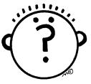
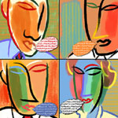 | I talk through my ideas, thoughts and feelings about what I’m reading.

When I am reading something, I can use the following things to help me:

I think about what might happen in the book and I can say why. | 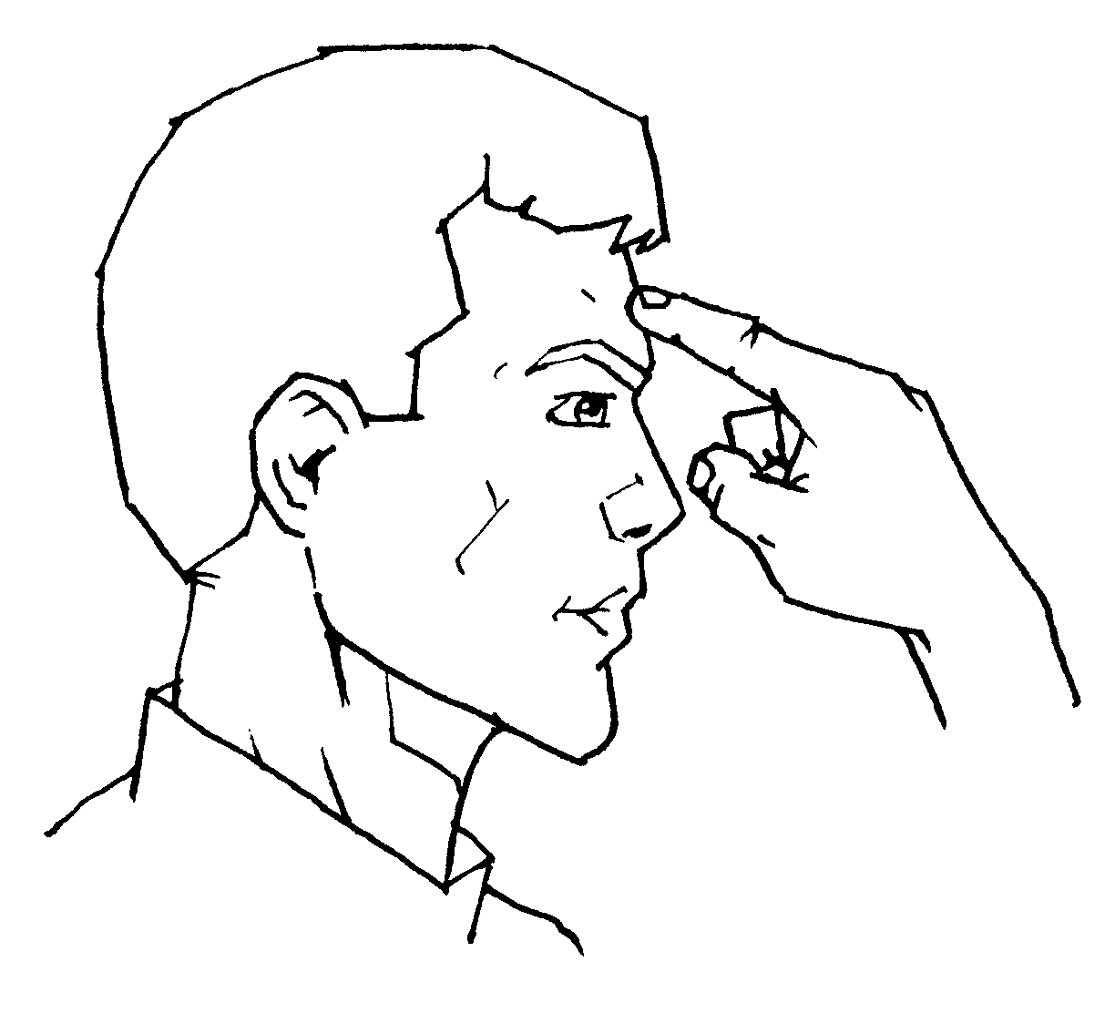
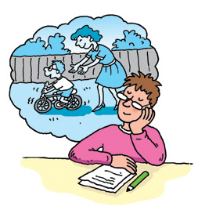 | When I read I imagine what is happening and create a picture in my mind.
I use words I can see around me or that I have read before. | 

